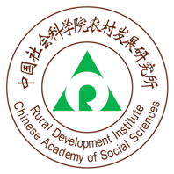
Application Form

Workshop Title: Systematic Innovation for Food Security and Rural Sustainability in China

UK Principal Investigator: Dr Bin Wu (University of Nottingham)
Partner Country
Principal Investigator: Dr Tongquan Sun (Chinese Academy of Social Sciences)

Dates and venue: 8-9 December 2021 (to be confirmed), Online and Offline

The Newton Fund Researcher Links programme provides opportunities for early career researchers from the UK and China to interact, learn from each other and explore opportunities for building long-lasting research collaborations. As part of this programme, we are now recruiting early career researchers to participate in the above Workshop.
The workshop will provide a unique opportunity for sharing research expertise and networking. Before the workshop early career researchers will have the opportunity to present their research through online meeting and discuss this with established researchers from the UK and China. There will be a focus on building up links for future collaborations and participants will be selected on the basis of their research potential and ability to build longer term links.
The Newton Fund and National Natural Science Foundation of China (NSFC) will cover the costs related to the participation to the workshop, including travel (both international and local), accommodation and meals. Costs for the visa, and travel insurance will be covered however, participants will be responsible for making all the necessary arrangements. The British Council accepts no responsibility for any problems which may occur with travel or accommodation arrangements or any other issues participants might experience when the participants are away from their home.

Application and Deadline:
The full application below must be completed and submitted by 15 September 2021 to: Wang Rui (wangrui@cass.org.cn)

Eligibility Criteria:
- Applications must be submitted using the Researcher Links application form.
- The application must be submitted before the above deadline.
- Participants must be Early Career Researchers: Early Career Researchers are defined as holding a PhD (or having equivalent research experience) and having up to 10 years post-PhD research experience.
- Participants must have a research or academic position (a permanent post, research contract, or fellowship etc) at a recognised research institution either in the UK or in China.
- Please note that participants are expected to attend all sessions of the workshop (both online and offline) including group meetings before the workshop.

Quality Assessment
  - Experience and relevance of the applicant’s research area to the workshop theme(s)
  - Motivation and contribution to the aims of the workshop
  - Description of the long-term impact expected through the participation in the workshop
  - Ability to disseminate workshop’s outcomes

Selection Procedure
  - Eligibility check
  - Quality assessment

Notification of results
Applicants will be notified via email by 30 September 2021

Equal Opportunities
Equal opportunities and diversity are at the heart of the British Council’s cultural relations ambition. While recognising that some research fields are dominated by one particular gender, Principal Applicants are encouraged to work towards an equal gender balance and promote diversity. They must not exclude applicants on the basis of ethnicity, gender, religious belief, sexual orientation, social status or disability. Participants’ selection undertaken by workshop organisers must not contravene this policy. Extra support to enable participation of Early Career Researchers with special needs will be given.

This work is supported by a Researcher Links grant, ID (2020-RLWK12-10436), under the UK-China partnership (Newton Fund). The grant is funded by the UK Department for Business, Energy and Industrial Strategy and National Natural Science Foundation of China (NSFC) and delivered by the British Council (BC).
Co-funded by: | Delivery partner:
 | 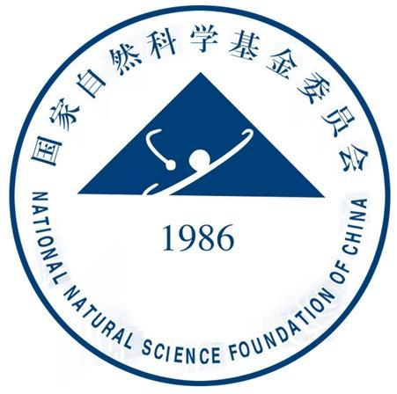
In partnership with:
James Hutton Institute (JHI), Chinese Academy of Agricultural Sciences (CAAS), China Agricultural University, University of Nottingham Ningbo China (UNNC), York University, Surrey University, Agricultural Engineering Precision Innovation (Agri-EPI) Centre, Beijing University of Technology, Just Rural Transition, International Conference on Agricultural and Rural Development in China (ICARDC) Network, and China-Britain Regional Initiative (CBRI).

Application Form
- Applicant
Name and Title
Gender (for statistical purposes. This will not affect choice of participants)
Position and institution
Postal address
Email
Phone number
Brief CV (academic career, publications - 5 selected items, markers of esteem, and any other relevant information) – no more than ½ page of A4

- Abstract – Please give a summary of your area of research [up to 100 words, outline of an academic paper should be written and submitted in a separated document]

- Please describe your motivation for attending the workshop and how the workshop matches your professional development needs

- Please describe the expected impact of your participation on your personal and professional development, including your ability to work international

- Please indicate how you will disseminate the outcomes of the workshops and the new knowledge/skills you have acquired

- Workshops will take place in English as standard. Please indicate your ability to work and communicate in English
Native speaker |  | Good
Excellent |  | Need support

- Bearing in mind the nature of interdisciplinary research, please provide your preferences among research themes below (or add a theme) by ranking (1 as most interested)
Ecological agriculture |  | Digital technology
Financial inclusion |  | Tourism & entrepreneurship
Other (please specify):

- Please use this space to give any additional information that you feel is relevant for the application

